**Cloud Computing Project Phase-1**

Amulya Kasaraneni

16265464

akffm@mail.umkc.edu

Step: 1 Click on Services -> Click on S3 and create a bucket

Step 2: Set permissions and click on next

Step 3: Successfully uploaded the dataset in S3 bucket

Step 4: Give the path of our uploaded dataset and click on verify

Step 5: Select the respective datatype and select the target

Step 6: Select the row id and click on review

Unfortunately, we are unable to create data sources and we came up with the following error.

Problems Faced:

Unable to implement by creating data sources

Lessons Learned:

AWS is giving access to its services based on our experience in machine learning.

Amazon sage maker is updated with in built functions which makes easy to beginners. So, it directs beginners to use Amazon sage maker for classification.

**Amazon sage maker:**

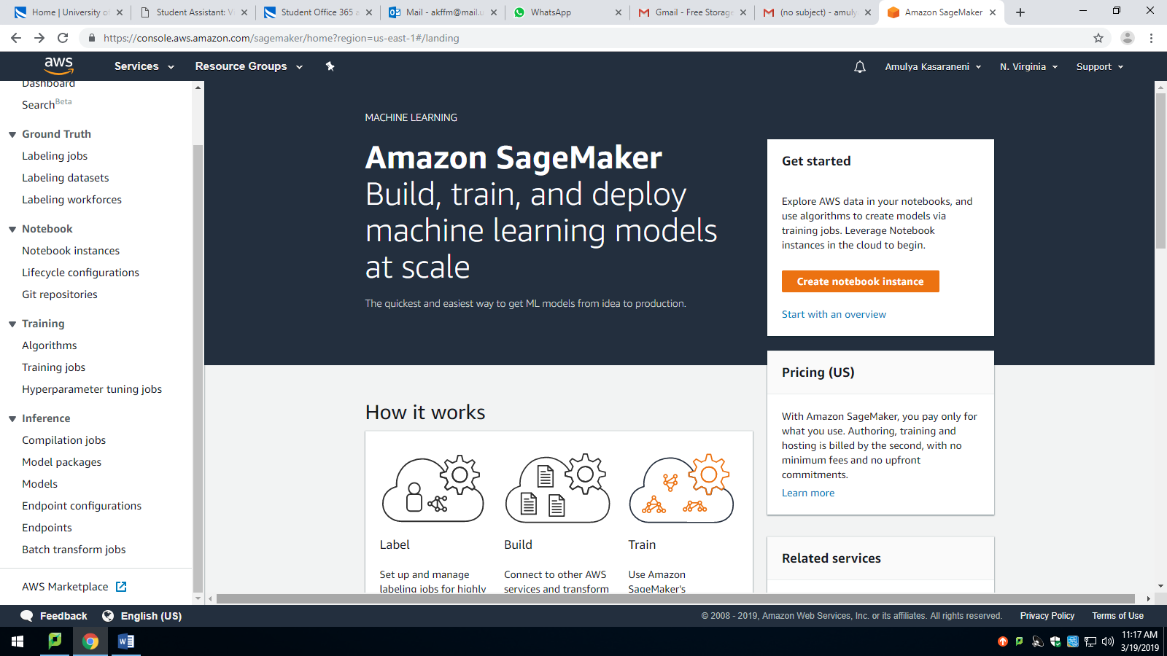

Step 1: Created a Notebook instance

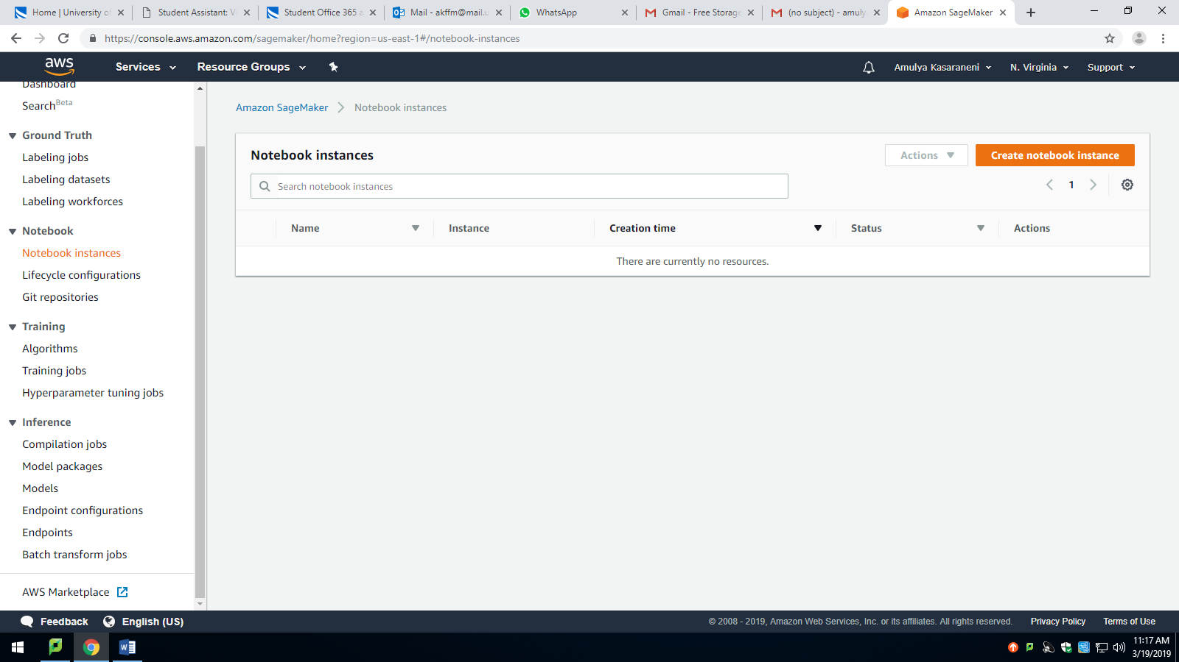

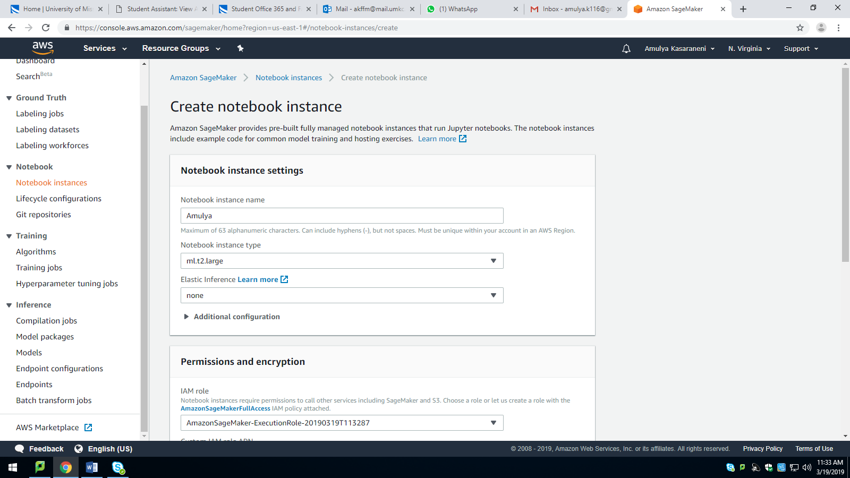

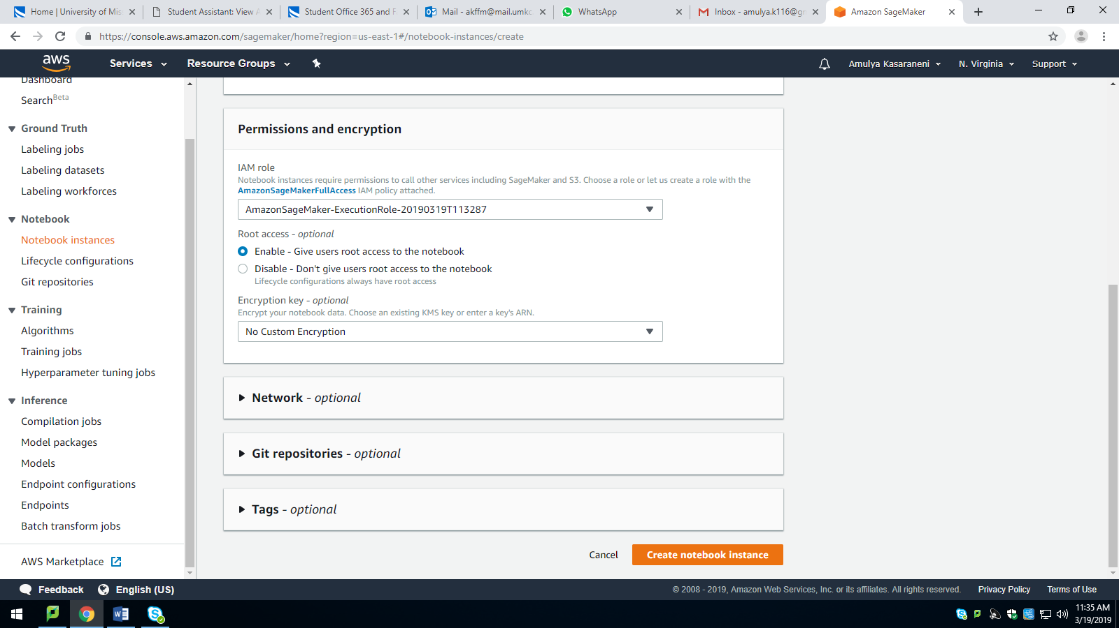

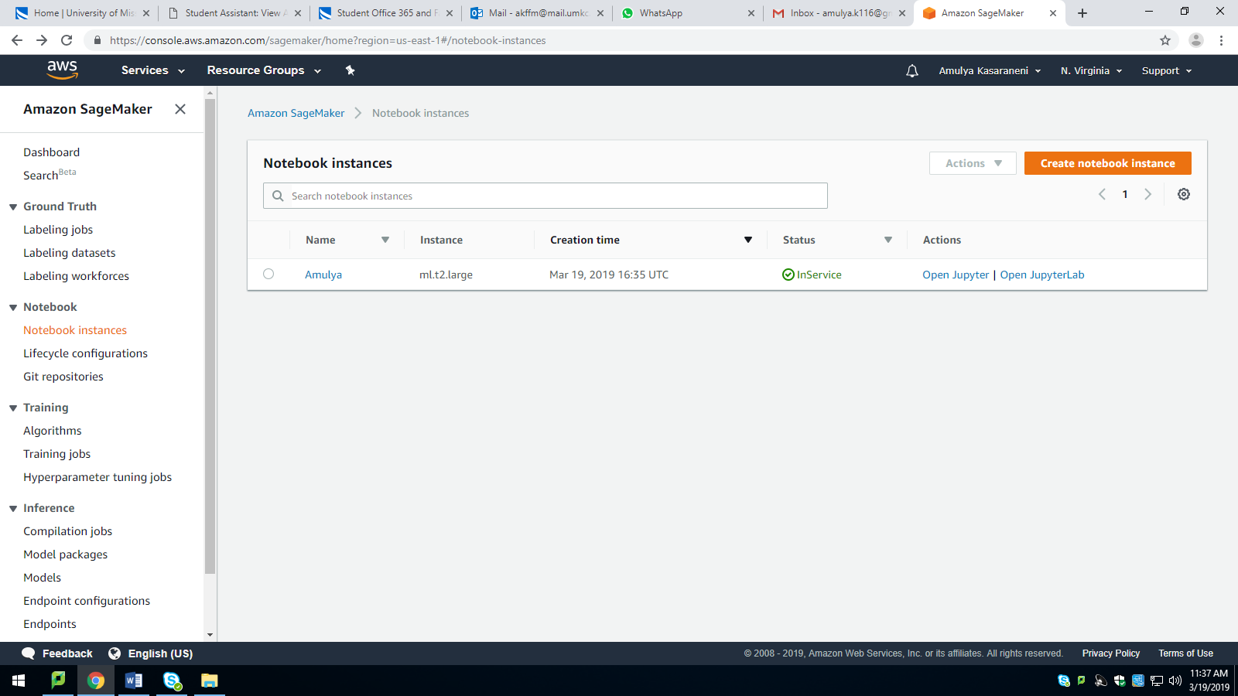

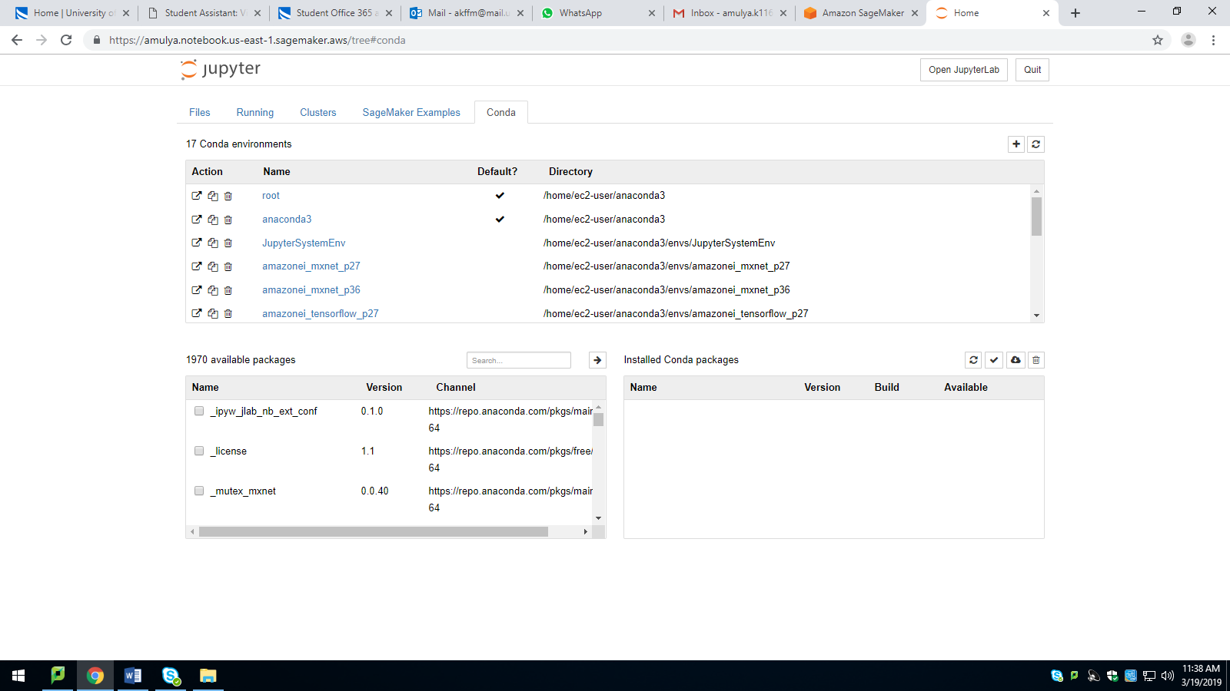

Progress:

Working on code

Planning to apply KNN Classification Algorithm and Logistic Regression

By next Phase:

I will submit the code and observations